May 11, 2004

Dear Rachel,

Attached please find the reconciliation forms and receipts of restaurant bills for the event of NSF ITR Summit (May 7 – May 10). (ITR Summit Day 2 Dinner)

Please put the charges to NSF ITR Construction Kit account # 66-7664.

A Summit meeting of faculty and students from both University of Colorado, University of Washington, and visiting faculty and researchers were conducted this past weekend. The attendees include Professor Mike Eisenberg, PI of the grant, his students in Computer Science from University of Colorado, and University of Washington (Design Machine Group faculty Co-PI Professor Mark Gross, and students involved with the grant), as well as visiting professor and researcher (McMurray, Finger, Sohn). Please see below for detail list.

NSF ITR grant, Computational Construction Kit attendee list….

Leah Buechley <Leah.Buechley@colorado.edu>,
Ann Eisenberg <annieandmike@earthlink.net>,
Nwanua Elumeze <nwanua@mac.com>,
Leah Buechley <Leah.Buechley@colorado.edu>,
Curtis Caravone <caravone@euclid.Colorado.EDU>,
Ellen Yi-Luen Do <ellendo@u.washington.edu>,
Mike Eisenberg <duck@cs.colorado.edu>,
Mark Gross <mdgross@u.washington.edu>,
Markus Eng <markuse@u.washington.edu>,
Ken Camarata <kcamarat@u.washington.edu>,
Mike Weller <philetus@u.washington.edu>,
Yeonjoo Oh <yeonjoo@u.washington.edu>,
James McMurray <mcmurray@u.washington.edu>,
Susan Finger <sfinger@ri.cmu.edu>,
Won-Sung Sohn <sohnws@rainbow.yonsei.ac.kr>

Since it's a full day event conference, so we have purchased several food items and I will be submitting them later when I get them organized.

Please let me know if you have any questions or if you need more information.

Thank you,

Ellen
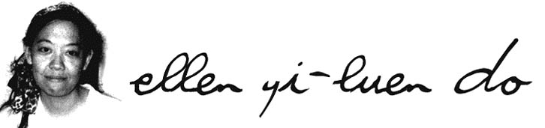
PROCARD RECONCILIATION

(One receipt per reconciliation form. Please write the transaction number on the receipt)

TRANSACTION NO. 397139 BUDGET NO. 66-7664

DATE OF PURCHASE 5/8/04

VENDOR NAME Mesob Ethiopian Restaurant

PURPOSE OF PURCHASE: ITR Summit Meeting

NSF Grant Planning Conference

DATE REVIEWED 5/10/04

After receiving your ProCard email Monday morning, please review your purchase(s). Attach this reconciliation to your receipt and return to Rachel/Nicole in 224 Gould by Thursday, 4:30 pm.

PROCARD RECONCILIATION

(One receipt per reconciliation form. Please write the transaction number on the receipt)

TRANSACTION NO. 397140 BUDGET NO. 66-7664

DATE OF PURCHASE 5/8/04

VENDOR NAME Sushi Kuma Restaurant

PURPOSE OF PURCHASE: ITR Summit Meeting

NSF Grant Planning Conference

DATE REVIEWED 5/10/04

After receiving your ProCard email Monday morning, please review your purchase(s). Attach this reconciliation to your receipt and return to Rachel/Nicole in 224 Gould by Thursday, 4:30 pm.

