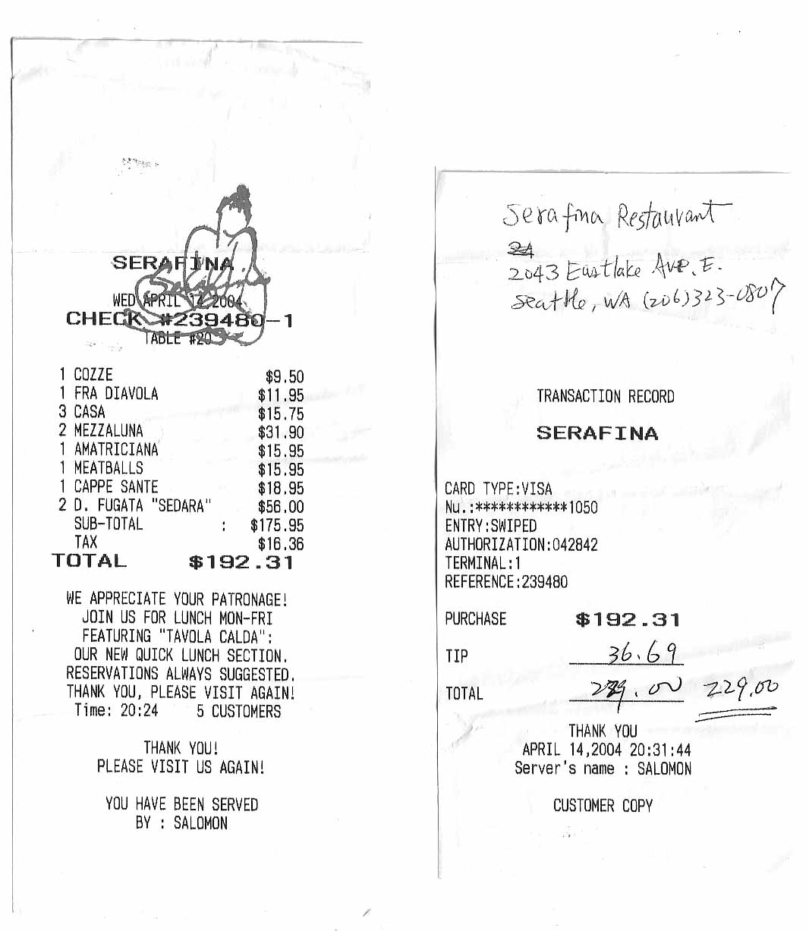
PROCARD RECONCILIATION

(One receipt per reconciliation form. Please write the transaction number on the receipt)

TRANSACTION NO. 385649 BUDGET NO. 64-1333

DATE OF PURCHASE 4/14/04

VENDOR NAME Serafina Restaurant

PURPOSE OF PURCHASE: Dinner for Faculty Candidate Visit

(Architecture, Michael Rios)

DATE REVIEWED 4/20/04

After receiving your ProCard email Monday morning, please review your purchase(s). Attach this reconciliation to your receipt and return to Rachel/Nicole in 224 Gould by Thursday, 4:30 pm.

