Introduction

The work displayed in this report is the result not only of an interdisciplinary and interdepartmental collaboration between Professor Ellen Do's Digital Design Studio, Arch 503, and Professor Dan Abramson's Urban Design Studio UrbDP 508, but also of part of an international collaboration with the School of Community and Regional Planning (SCARP) at the University of British Columbia, Vancouver, B.C. which took place over two consecutive weekends in the Fall Quarter 2001, Oct. 26-27 and Nov. 2-3. With generous support from the UW Canadian Studies Center, the UW team was able to visit Vancouver for two days of site visits and joint design work, and then, a week later, they hosted the UBC team in Seattle. Building on previous occasional exchanges with UBC's SCARP in years past, the Fall 2001 exchange was the most intensive and design-oriented of any so far, and was the first to involve actual charrettes – one in each city. The work presented here is the creation of the second of these charrettes.
The theme of the exchange was "intensification of the urban fabric" – in particular the integration of high-density housing with other uses in areas where former industrial uses or auto-oriented suburban development has left large tracts of vacant land in close proximity to expanding urban or transit centers - and the implications of intensification for streetscape design. In addition to study tours in Vancouver and Seattle involving site visits and presentations by public and private-sector planners and designers, the exchange required students from the two universities to work together in teams for quick, one-day policy and design charrettes on a specific problem in each city.
The UW group first visited the joint ICBC-TechBC campus-office-shopping site in Surrey Centre; Burnaby's Metrotown; and Vancouver's False Creek North area. In Vancouver, the subject of the charrette was the street design of Pacific Boulevard as it passes BC Place stadium, a major high-density mixed-use area planned in concert by the City of Vancouver and the Concord Pacific development company. Background information and feedback was provided by Vancouver City Planner Michael Gordon, and among the reviewers was Allen Jacobs, visiting from the University of California at Berkeley.

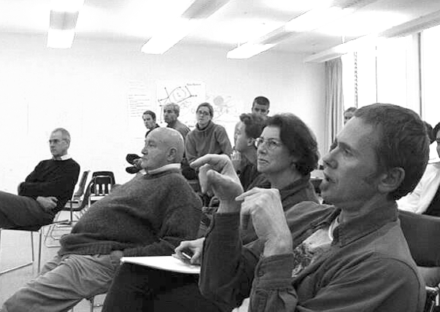
Vancouver City Planner Michael Gordon comments on student work at the UBC Charrette, as Profs. Tony Dorcey (Director of UBC's SCARP), Allan Jacobs, and Penny Gurstein look on with CAUP students Chris Meek, Morgan Elliott, Joanna Day, and Dominik Bueckers (Photo by Ellen Do).

In Seattle, the teams visited the Millenium Tower and Harbor Steps projects, and the charrette addressed possibilities for the revitalization of the area around Northgate Mall, an historic example of American auto-oriented retail development that is increasingly challenged by rapid urban growth and congestion.
Designated by Seattle's Comprehensive Plan as an Urban Center intended for increased residential and employment densities, access to future rapid transit, diversity of activity, and pedestrian friendliness, Northgate arguably has the farthest to go of any of the five areas so designated (the others being Downtown, First Hill/Capitol Hill, Uptown Queeen Anne, and the University Community). The area is characterized by drive-in and big-box retail surrounded by parking lots. Zoned NC3 in an Overlay District that encourages mixed-use development, there is currently no mixed-use on any single property in Northgate. Although there is a major Metro bus transit hub and park-and-ride in the neighborhood, plans by Sound Transit to build its light rail terminus at Northgate have been put on hold in favor of building the southern portion of its line first, from SeaTac Airport to Downtown, and then -- whenever funds allow -- only to the University District.
The Northgate site has been the subject of numerous studies by UW design faculty and students, the City of Seattle, developer teams, and community groups. Over the years, the focus of this attention has shifted gradually, according to the opportunities that have seemed most relevant at the time. Early studies of the transit issues, including the supplementing of rapid transit with neighborhood-scale people-movers (in a studio taught by Urban Design and Planning Professor Ron Kasprisin), were followed by Kristina Hill's studio in Landscape Architecture and Ellen Do's Digital Design Studio in Architecture that collaboratively explored the daylighting of Thornton Creek in the South Lot of the Mall property in Fall 2000.
The collaboration between Hill and Do in 2000 formed an experiential basis for the collaboration documented in 2001, documented in this report. By Fall 2001, with transit held up by changes in Sound Transit's plans, and the fate of the South Lot locked up in a legal battle between the City and the Thornton Creek Legal Defense Fund, the city and community found a new focus for discussion: the nature of the streets surrounding the Mall property itself, given gradual future development around the mall, along these streets, and including in particular a new community center and library in the neighborhood. This was the subject of the collaboration between Arch 503 and UrbDP 508, and between UW-CAUP and UBC-SCARP in Fall 2001, which altogether lasted only three-and-a-half weeks. Following the two weeks spent with UBC, an additional ten days were spent by the Digital Design and Urban Design students in further developing their team's schemes, presented in this report. They reflect the layering of issues that has built up in Northgate over the years, from the detailed design of stream daylighting as it influences street crossings and intersections, to the integration of rapid transit and neighborhood street patterns with expansion of the mall.
These schemes and their further separate developments in the Digital Design and Urban Design studios were presented at a Community Open House on December 13, 2001, and were reviewed by senior staff from the Seattle Planning Commission, Design Commission and City Design, Seattle Public Library, Parks and Recreation, Strategic Planning Office and Seattle Public Utilities.
The complete online documentation of the Digital Design Studio Fall 2001 work on Northgate can be viewed at http://dds.caup.washington.edu/au01/index.html

