David W. DiPuma
ARCH 484: DMG Seminar
Dec. 17, 2002

The following report is a collection of the main topics discussed during the quarter seminar. All the topics relate or pertain to the field of architecture, and will be discussed accordingly. Below, a small summary of each topic will be presented with a paragraph explaining the advantages or disadvantages the particular topic has in relation to the field of architecture from a student’s standpoint. As a master’s student in the college of Architecture and Urban Design, this seminar provided a variety of alternative routes for expressing and creating future design projects and works of art.

- MouseHaus Table presented by Chen-Je Huang.

MouseHaus simulates pedestrians' activity in a virtual environment in order to visualize the patterns that underlie the decisions of architects and urban designers. An architect could use this to test a design before it is built. Based on the study of real pedestrian activity in an urban space, MouseHaus provides a simulated world in which pseudo-pedestrians make decisions about how to behave.
This simulation was further developed by Chen-Je Huang as a “hands-on” application. Mr. Huang created the MouseHaus Table so that physical blocks or pieces of paper could be easily moved around on a surface to represent the locations of the buildings within the simulation. Why is this more efficient than locating the buildings within the software? By providing an application for maximum flexibility between users, the MouseHaus Table allows multiple users to interact with the software at the same time. This allows teams of urban designers to create multiple scenarios at any one given time.
Advantages: Personally, I see the great advantages to this new application to the existing software. As an architectural student, I found the MouseHaus software to be a valuable design tool for urban planning and design. To understand the people who occupy our buildings is to understand the environments themselves.
Disadvantages: Mr. Huang should further develop his application to include one or two more variables. One, the height of buildings is very important to the movement of people. This application has great potential to include this important aspect for the colored squares of paper can be building blocks representing heights of buildings. Using the technology already instilled in the application, the possibility of locating a second and third camera would help to create a 3-dimensional world within the software. The current camera is located above the surface plane looking perpendicular to the table’s surface. For now, lets say this takes into account the Z-axis. By locating two cameras on the sides of the surface, just above the plane, will take into account the X-axis and Y-axis. Combining all the information taken from these three cameras will govern the creation of a 3-dimensional would within the software for the simulations. I understand the X and Y camera cannot determine depth but only 2d planes so it will be hard to collaborate the three composite groups of information. That is for Mr. Huang to figure out. A possibility would be to develop a grid system represented in a specific color directly opposite of each camera that would allow the cameras to give a set location (or points) of each surface it sees. The buildings heights and locations would be projected onto the 2d grid surface for data collection. The software would then combine the co-ordinance collected from the three cameras to create a 3d world for simulation. See diagrams below.
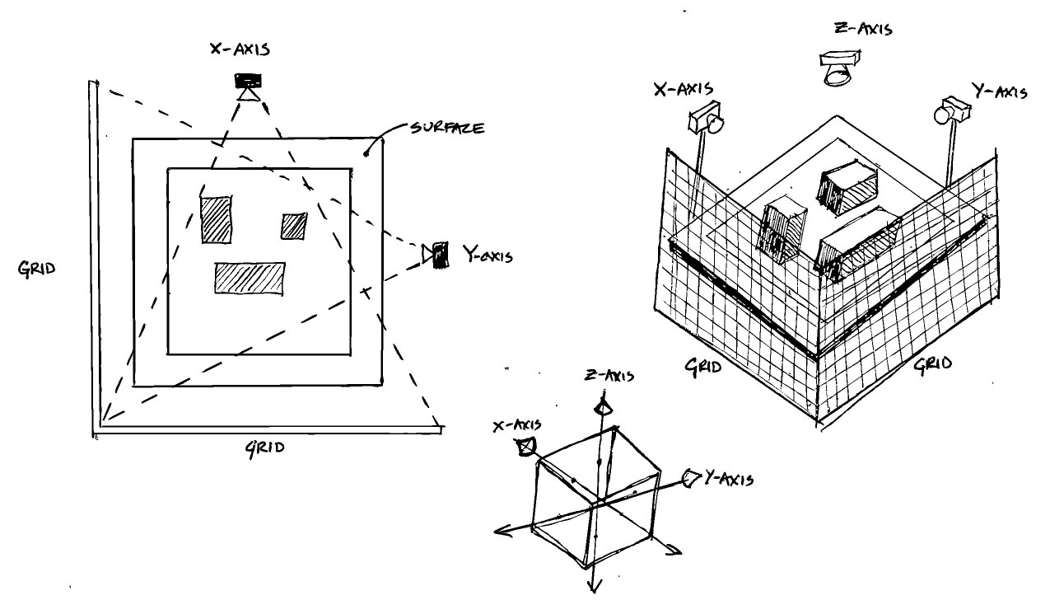

By having the heights of the buildings, a second variable can be added, the casting of shadows from the sun. Sun light also plays a large role in the movement and congregation of pedestrians in public areas.
Overall, I found this software to be a very good design tool for urban planning as well as the future understanding of pedestrian movement through spaces.
- SPOT…Fetch Sunlight presented by Sebastien Bund.
This particular software deals with the mapping of or the simulation of direct sunlight into a virtual 3d building. Mr. Bund is trying to develop a software that can be combined with the current Space Pen software to simulate the penetration of direct sunlight onto and within a building, with the flexibility to change the time and location of the sun’s position as well as map the sun’s penetration within the building over given periods of time. The study of direct sunlight is very important to the development of a functionally built environment. Today, architectural firms will spill countless amounts of resources into the study of natural sunlight into a building.
SPOT…Fetch Sunlight has the possibilities not only to map the path of direct sunlight but also the integration of natural sun lighting solutions. A positive addition to the current application would be the development of a library of natural sun lighting solutions, which could be used in the virtual 3d model for further design development.
Advantages: This application has great use in the architectural world as a great design tool. By understanding the relationship of the sun to a given building is very important to the overall functionality of the structure. For example, if the project is a school, the effects of direct sunlight into the classroom creates a negative learning environment. Determined by the Lighting Lab here in Seattle, direct sunlight decrease attention in classrooms and effects students’ ability to comprehend their studies. This software will help in developing built solutions.
Disadvantages: As mentioned before, the integration of design solutions pertaining to sunlight would be a great added feature to the current application.
- Digital Souvenir presented by Doo Young Kwon.
The Digital Souvenir was the creation of personal virtual environments with a navigation in a physical environment. The object, space, and structure become the “tokens of remembrance” obtained by the Digital Souvenir. The physical objects as well as pictures would be stored in digital towers located throughout the environment. These towers would store our personal memories of the surrounding environment for us to observe at a later time. The Digital Souvenir is like a digital camera except it is a stationary tower that takes more than just pictures.
Advantages: The towers would be great for those times when you wish you could capture the moment. It also allows us to control and govern a singular database of our memories, kind of like the human brain. This was not clear, but if the towers could obtain data from 3d objects, for example, create a virtual model of the objects, this would be great for future trips down “memory lane.”
Disadvantages: The cost of these towers would be outrageous. The location would have to be every 2 feet for maximum coverage and flexibility. This is impossible. That is why we have cellular phones with Internet connection and digital cameras. The towers hold no personal connection to the use like an individual item (i.e. cell phone). Also, the development of virtual models of objects defeats the purpose of buying souvenirs all together. This would destroy this particular market of business.
The idea of the towers may not work, but the idea of the digital souvenir itself is very interesting. It would be very innovative to see this idea integrated into the structure of a building. A “smart” building, which has the capabilities to record and story all your memories while you are in the building. The way of the future, I don’t see why not!
- Visio presented by Paul Lewis (Visio Corporations)
“A better way to draw.” These were the words of Mr. Lewis describing his new software Visio. Visio is an application like AutoCAD and AutoDesk, but was created to make drawing as simple as possible. This new software deletes the use of line commands and hundreds of icons and creates an infrastructure of just a few key commands. By creating “smart” objects, drawing is made simple by providing the syntax and semantics of drawing. The behavior of the objects within the drawing framework is specific to a drawing domain. Therefore, objects understand and know their own domain. This results in a reduction in the learning curve most often required for this particular type of software. Confusion due to modality is also reduced. The overhead of abstraction, which marks the framework of drawing, is reduced. And ideally, those who “can’t draw…can.”
Advantages: The application creates a more accessible way to draw. It requires a very low knowledge about drawing, which allows more people to use the software. It also does not stand between the user and the problem at hand.
Disadvantages: The market for this type of software is very small. The average person would not buy this software for an at-home use. The typical user will most likely already know how to draw. Also, in today’s developing technological world, most drawing software allow the users to create 3d models. Most of these types of software create virtual models as the user draws. This advantage allows the user to virtual models as a design tool. This particular software does not allow any 3-dimensional development. I find this as an architectural student to be a strong point against the usefulness of this particular software.

I really enjoyed the seminar this quarter and I plan on take the physical computing class as well. Thank you for all the wonderful and interesting presentations. David

